 | ISCG6423 Database Design and Development  Semester 2, 2025  Database Design Assignment
School of Computing, Electrical and Applied Technology | Course Weighting: 40%  Due Date: Week 9 (exact time: TBA)  Total Marks: 100

Learning outcome:

4. Develop a physical database design from a given logical design.

Assignment instructions:

- This is a group (of two) assignment.
- You will be assigned a case study by the lecturer.
- You will develop a physical database design from a logical design of a database application for a given case study.
- You are permitted to use AI tools to assist in completing this assignment. However, you must be able to fully explain and justify your work during an oral interview. If you cannot demonstrate an adequate understanding of the concepts, processes, or reasoning behind your submission, I reserve the right to base your grade solely on your interview performance rather than the submitted work.

Task

You will develop a physical database design from a given logical design of a database application for a business mentioned in the allocated case study.

  - Develop a data volume map. (5 marks)

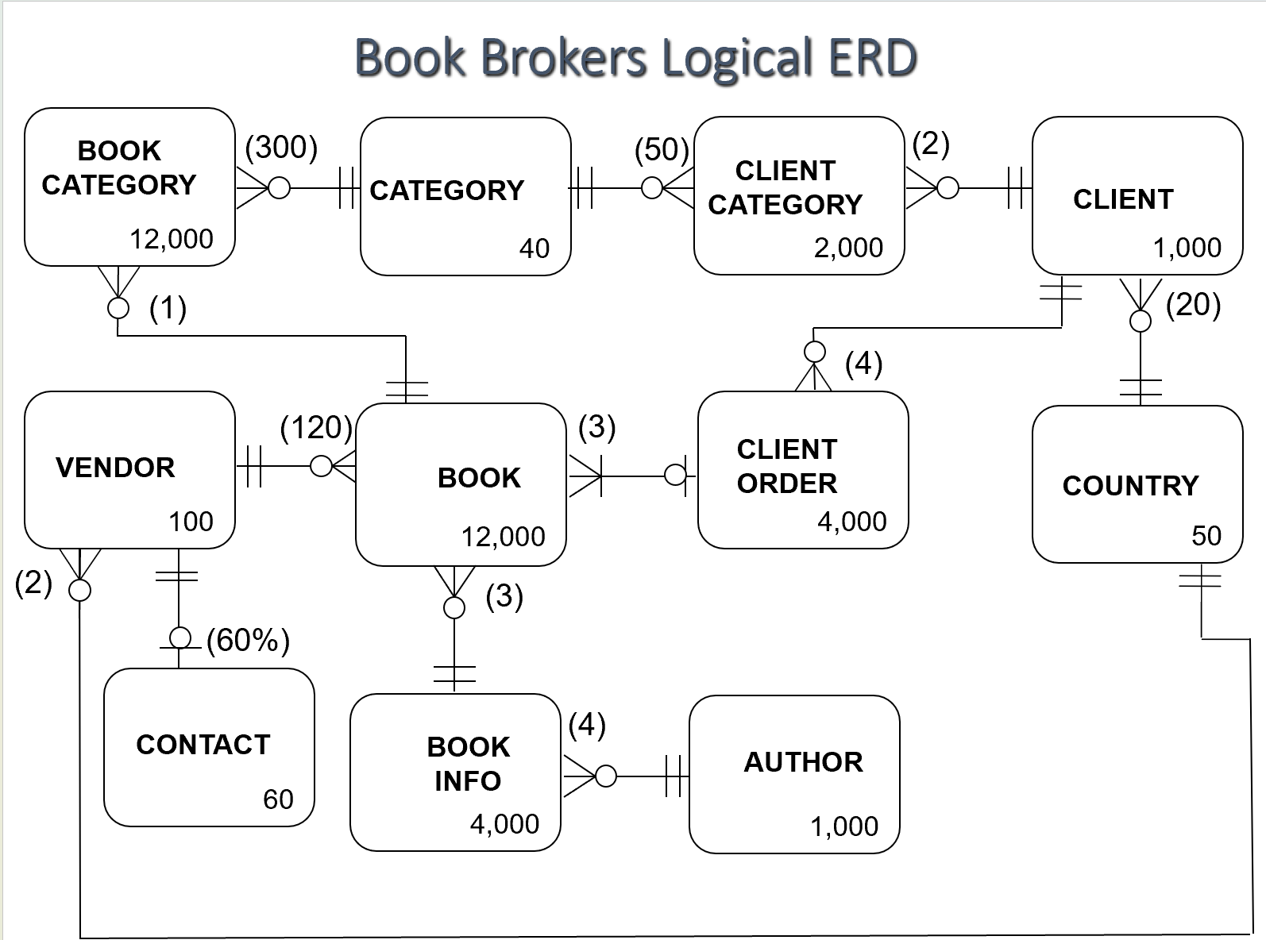

  - Develop two data usage maps for the two most important business processes. (5 marks)
- All shipped orders for all clients run on average 4 times a day
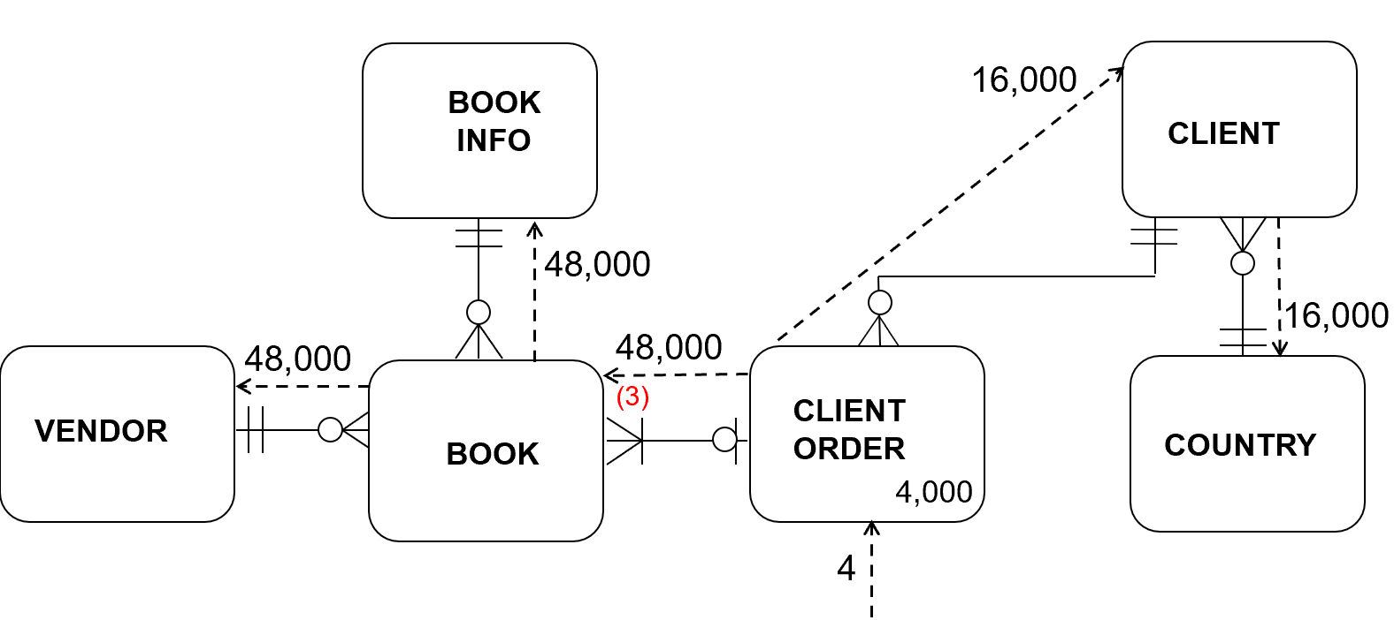

- All vendors and available books run on average 3 times a day
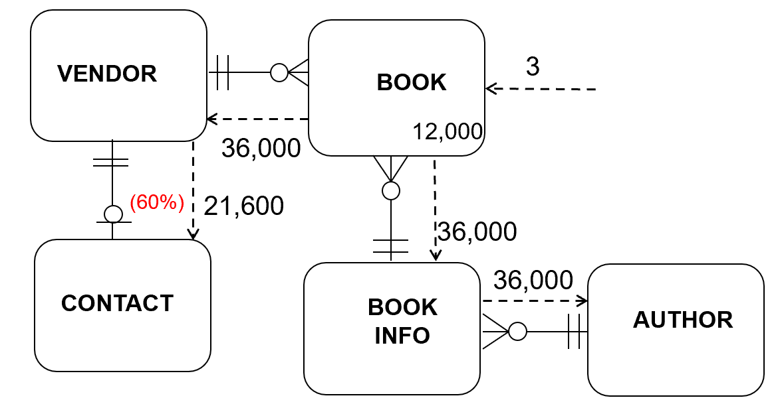
  - Complete the business processes in the physical design techniques matrix table using the business processes. You must use “YES’ or “NO” to complete the matrix. (10 marks)
 | De-Normalisation |  |  | Duplication | Partitioning |  | Indexing
Processes \ Techniques | One-to-one | Associative Entity | One-to-many |  | Horizontal | Vertical
1. Enter, modify or delete clients | no | no | no | yes | no | no | yes
2. Enter, modify or delete vendors | yes | no | no | yes | no | no | yes
3. Enter, modify or delete books | no | no | yes | yes | no | no | yes
4. Enter, modify or delete client orders | no | no | no | yes | no | no | yes
5. Add or remove categories to or from books and clients | no | no | yes | yes | no | no | yes
6. Mark a client order as shipped or paid | no | no | no | yes | no | no | yes
7. All vendors and unavailable books | yes | no | yes | yes | yes | no | yes
8. All vendors and available books | yes | no | yes | yes | yes | no | yes
9. All shipped orders for all clients | no | no | no | yes | yes | no | yes
10. All clients | no | yes | no | yes | no | no | yes
11. Books by vendor | no | no | no | yes | no | Yes | yes
12. Books by client | no | no | no | yes | no | Yes | yes

  - Use the information from the data maps (that you completed in questions 2 & 3) and the matrix (that you have completed in question 4) to help you consider the application of physical design techniques to each of the business processes. (30 marks)
Processes \ Techniques | One-to-one | Associative Entity | One-to-many | Duplication | Horizontal Partitioning | Vertical Partitioning | Indexing
1. Enter, modify or delete clients | no | no | no | yes | no | no | yes
For the “Enter, modify or delete clients”. I won’t apply Duplication technique. I will use indexing technique to enhance the performance.

List clients
Current SQL:
Select ClientID, FirstName, LastName, StreetAddress, Suburb, City, CreditStatus, CountryName, PhoneNumber
From Client, Country
Where Client.CountryID = Country.CountryID
Order by LastName, FirstName
List countries
Select *
From Country
Order by CountryName

The indexing technique can be used by creating three indexes: one on the LastName and FirstName in the Client table, the second on the CountryID in the Client table, the last on the CountryID in the Country table.

CREATE INDEX ClientName_IDX ON Client (LastName, FirstName);
CREATE INDEX ClientCountry_IDX ON Client (CountryID);
CREATE INDEX CountryName_IDX ON Country (CountryName);

The performance of this report will be enhanced because the three new indexes allow the database engine to quickly locate and sort records without scanning the entire table. These indexes reduce query response time.

The disadvantages of using this technique is that the processes will be made slower during data modification operations such as INSERT, UPDATE, and DELETE, because the database must also update the relevant indexes.

Although “Enter, modify or delete clients” is not an important process, the indexing will not slow down any important process because CountryID, LastName and FirstName is not volatile. LastName, FirstName and CountryID are always used in order by clause. I decide to create the previous two indexes. I won’t create the CountryName_IDX, because CountryName is not big and it is not used in any report process.

Processes \ Techniques | One-to-one | Associative Entity | One-to-many | Duplication | Horizontal Partitioning | Vertical Partitioning | Indexing
2. Enter, modify or delete vendors | yes | no | no | yes | no | no | yes

For the “Enter, modify or delete vendors”. I won’t apply the Duplication technique. I will use the One-to-one denormalisation and Indexing technique to enhance the performance. I just introduced the One-to-one denormalisation technique.
List vendors
Current SQL:
Select VendorID, VendorName, CountryName, LastName, FirstName, Contact.Email
From Vendor,Country,Contact
Where Contact.VendorID = Vendor.VendorID
and Vendor.CountryID = Country.countryID
Order by vendorname

The one-to-one de-normalisation technique can be used by combining the Contact and Vendor entities so that LastName, FirstName and Email are now stored in the Vendor table.

The performance of this report will be enhanced because it can benefit from losing one extra join in sql so we go ahead and do the denormalization so we get rid of one entity .

The disadvantage of using this technique is that the process “Enter, modify or delete vendors” will be harder, for 60% of ventor we have two extra attribute to fill out, second there will 40% null in the table which is not desirable.

However, as the two entities will be used in an important process(All Vendors and available Books), I decide to sacrifice other process’s running time to make this one faster.

Revised table and SQL:
VENDOR (VendorID, VendorName, CountryID*, Email, ContactLastName, ContactFirstName, ContactEmail)
Select VendorID, VendorName, CountryName, ContactLastName, ContactFirstName, ContactEmail
From Vendor, Country
Where Vendor.CountryID = Country.countryID
Order by vendorname

For Indexing, I create an index on vendorname in vendor table because more than one process use the vendorname within order by clause.
CREATE INDEX VendorName_IDX ON Vendor (vendorname);

Processes \ Techniques | One-to-one | Associative Entity | One-to-many | Duplication | Horizontal Partitioning | Vertical Partitioning | Indexing
3. Enter, modify or delete books | no | no | yes | yes | no | no | yes

For ” Enter, modify or delete books”, I won’t apply the Duplication technique. I will use the One-to- many denormalisation and Indexing technique to enhance the performance. I just introduced the One-to-many denormalisation technique.

List book info
Current tables and SQL:
AUTHOR (AuthorID, LastName, FirstName)
BOOKINFO (BookInfoID, Title, AuthorID*, Notes)

Select BookInfoID, Title, AuthorID, Notes, FirstName, LastName
From BOOKINFO, AUTHOR
Where AUTHOR. AuthorID = BookInfo. AuthorID
Order by Title

The one-to-many (reference data) de-normalisation technique can be used by combining the AUTHOR and BOOKINFO type entities so that AUTHOR data is now stored in the BOOKINFO table.

The performance of this report will be enhanced because it can benefit from losing one extra join in sql so we go ahead and do the denormalization so we get rid of one entity.

The disadvantage of using this technique is that the process “Enter, modify or delete bookinfos” will be harder, for BookInfo we have two extra attribute to fill out.

However, as the two entities will used in an important process (All Vendors and available Books) and they are searched 36,000 per day. I decide to combine the author data into BookInfo table.

Revised table and SQL:
BOOKINFO (BookInfoID, Title, LastName, FirstName, Notes)

Select BookInfoID, Title, AuthorID, Notes, FirstName, LastName
From BOOKINFO
Order by Title

Processes \ Techniques | One-to-one | Associative Entity | One-to-many | Duplication | Horizontal Partitioning | Vertical Partitioning | Indexing
4. Enter, modify or delete client orders | no | no | no | yes | no | no | yes

For the “Enter, modify or delete client orders”. I won’t apply Duplication technique. I will use indexing technique to enhance the performance.

List Books
Current SQL:
Select BookID, Price, Available, DatePublished, Title, VendorName
From BOOK, BOOKINFO, VENDOR
Where VENDOR.VendorID = BOOK.VendorID
and BOOK .BookInfoID = BOOKINFO .BookInfoID
Order by Title

The indexing technique can be used by creating three indexes: one on the Title in the BOOKINFO table, the second on the BookInfoID in the BOOK table, and the last on the VendorID in the BOOK table.

CREATE INDEX InfoTitle_IDX ON BOOKINFO (Title);
CREATE INDEX BookInfoID_VendorID_IDX ON BOOK (BookInfoID, VendorID);

The performance of this report will be enhanced because the two new indexes allow the database engine to quickly locate and sort records without scanning the entire table. These indexes reduce query response time.

The disadvantages of using this technique are that the processes will be made slower during data modification operations such as INSERT, UPDATE, and DELETE, because the database must also update the relevant indexes.

Although “Enter, modify or delete client orders” is not an important process, the indexing will not slow down any important process because BookInfoID, VendorID and Title are not volatile. I decide to create the three indexes.

Processes \ Techniques | One-to-one | Associative Entity | One-to-many | Duplication | Horizontal Partitioning | Vertical Partitioning | Indexing
5. Add or remove categories to or from books and clients | no | no | yes | yes | no | no | yes
For the “Add or remove categories to or from books and clients”. I won’t apply Duplication technique. I will use indexing and One-to-many technique to enhance the performance. I just introduced the Duplication technique for this process.
List books
Current SQL:
Select BookID, Price, Available, DatePublished, Title, LastName, FirstName
From AUTHOR, BOOKINFO, BOOK
Where BOOK.BookInfoID = BOOKINFO.BookInfoID
and BOOKINFO.AuthorID = AUTHOR.AuthorID
Order by Title, BookID

The duplications technique can be used by adding Title, LastName and FirstName to the Book table.

The performance of this report will be enhanced because it benefits from losing the one extra join in sql.

The disadvantage of using this technique is that the process will be harder, for Book table we have three extra fields to fill out.

However, as “Add or remove categories to or from books and clients” is not an important process, I decided not to use the technique on this process.

Processes \ Techniques | One-to-one | Associative Entity | One-to-many | Duplication | Horizontal Partitioning | Vertical Partitioning | Indexing
6. Mark a client order as shipped or paid | no | no | no | yes | no | no | yes
For the “Mark a client order as shipped or paid”. I won’t apply Duplication technique. I will use indexing technique to enhance the performance.

Current SQL:
List client orders
Select ClientOrderID, OrderDate, Status, LastName, FirstName
From CLIENT, CLIENTORDER
Where CLIENTORDER.ClientID = CLIENT.ClientID
Order by LastName, FirstName
List of books
Select BookID, Price
From BOOK
Where BOOK.ClientOrderID = ?

The indexing technique can be used by creating two indexes: one on the ClientOrderID in the BOOK table, another on the ClientID in the CLIENTORDER table.

CREATE INDEX OrderClientID _IDX ON CLIENTORDER (ClientID);
CREATE INDEX BookClientOrder_IDX ON BOOK (ClientOrderID);

The performance of this report will be enhanced because the two new indexes allow the database engine to quickly locate and sort records without scanning the entire table. These indexes reduce query response time.

The disadvantages of using this technique are that the processes will be made slower during data modification operations such as INSERT, UPDATE, and DELETE, because the database must also update the relevant indexes.

Although “Mark a client order as shipped or paid” is not an important process, the indexing will not slow down any important process because ClientID and ClientOrderID are not volatile and they will be used in an important process “All shipped orders for all clients”. I decide to create the three indexes.

Processes \ Techniques | One-to-one | Associative Entity | One-to-many | Duplication | Horizontal Partitioning | Vertical Partitioning | Indexing
7. All vendors and unavailable books | yes | no | yes | yes | yes | no | yes
For the “All vendors and unavailable books”. I won’t apply Duplication technique. I will use the One-to- one, One-to- many denormalization, Horizontal Partitioning and Indexing technique to enhance the performance. I just introduced the Horizontal Partitioning technique.

Current SQL:
Select VendorID, VendorName, Price, CONTACT.LastName, CONTACT.FirstName, BOOK.BookID, Title, AUTHOR.LastName, AUTHOR.FirstName
From VENDOR, BOOK, BOOKINFO, CONTACT, AUTHOR
Where Available = ‘No’
and BOOK.BookInfoID = BookInfo. BookInfoID
and BookInfo.AuthorID = AUTHOR.AuthorID
and BOOK.VendorID = Vendor.VendorID
and BOOK.VendorID = CONTACT.VendorID
Order by VendorName, Title

The horizontal partitioning technique can be used by partitioning the Book table on the Available attribute.

The performance of this report will be enhanced because it benefits from losing a filter in sql.

The disadvantages of using this technique is that the process “add, modify or delete books” will be made harder and the process “Books by vendor” will made slower because data is stored in two tables.

Though “All vendors and unavailable books” is not an important process, the next “All vendors and available books” is an important process. I decided to divide the table into two tables.

Revised tables and SQL:
BookAvailable (BookID, Cost, Price, Available, DatePublished,
BookInfoID*, VendorID*, ClientOrderID*)
BookUnavailable (BookID, Cost, Price, Available, DatePublished,
BookInfoID*, VendorID*, ClientOrderID*)

Select VendorID, VendorName, Price, Vendor.LastName, Vendor.FirstName, Title, BookUnavailable.BookID, BookInfo.LastName, BookInfo.FirstName
From VENDOR, BookUnavailable, BOOKINFO
Where BookUnavailable.BookInfoID = BookInfo. BookInfoID
and BookUnavailable.VendorID = Vendor.VendorID
Order by VendorName, Title

Processes \ Techniques | One-to-one | Associative Entity | One-to-many | Duplication | Horizontal Partitioning | Vertical Partitioning | Indexing
8. All vendors and available books | yes | no | yes | yes | yes | no | yes
For the “All vendors and available books”. I won’t apply Duplication technique. I will use the One-to- one, One-to- many denormalization, Horizontal Partitioning and Indexing technique to enhance the performance. I just introduced the Horizontal Partitioning technique.

Current SQL:
Select VendorID, VendorName, Price, CONTACT.LastName, CONTACT.FirstName, BOOK.BookID, Title, AUTHOR.LastName, AUTHOR.FirstName
From VENDOR, BOOK, BOOKINFO, CONTACT, AUTHOR
Where Available = ‘Yes’
and BOOK.BookInfoID = BookInfo. BookInfoID
and BookInfo.AuthorID = AUTHOR.AuthorID
and BOOK.VendorID = Vendor.VendorID
and BOOK.VendorID = CONTACT.VendorID
Order by VendorName, Title

The horizontal partitioning technique can be used by partitioning the Book table on the Available attribute.

The performance of this report will be enhanced because it benefits from losing a filter in sql.

The disadvantages of using this technique is that the process “add, modify or delete books” will be made harder and the process “Books by vendor” will made slower because data is stored in two tables.

As “All vendors and available books” is an important process. I decided to divide the table into two tables.

Revised tables and SQL:
BookAvailable (BookID, Cost, Price, Available, DatePublished,
BookInfoID*, VendorID*, ClientOrderID*)
BookUnavailable (BookID, Cost, Price, Available, DatePublished,
BookInfoID*, VendorID*, ClientOrderID*)

Select VendorID, VendorName, Price, Vendor.LastName, Vendor.FirstName, Title, BookAvailable.BookID, BookInfo.LastName, BookInfo.FirstName
From VENDOR, BookAvailable, BOOKINFO
Where BookAvailable.BookInfoID = BookInfo. BookInfoID
and BookAvailable.VendorID = Vendor.VendorID
Order by VendorName, Title

Processes \ Techniques | One-to-one | Associative Entity | One-to-many | Duplication | Horizontal Partitioning | Vertical Partitioning | Indexing
9. All shipped orders for all clients | no | no | no | yes | yes | no | yes
For the “All shipped orders for all clients”. I will use the Duplication, Horizontal Partitioning and Indexing technique to enhance the performance. As Horizontal Partitioning is similar with “All vendors and unavailable books”, I mainly introduced the Duplication technique.

Current SQL:
Select ClientID, LastName, FirstName, StreetAddress, Suburb, City, CountryName, ClientOrder.ClientOrderID, OrderDate, Book.BookID, Title, Price, VendorName
From VENDOR, BOOK, BOOKINFO, COUNTRY, CLIENT, CLIENTORDER
Where Status = ‘Shipped’
and CLIENTORDER.ClientID = CLIENT.ClientID
and CLIENT.CountryID = COUNTRY.CountryID
and BOOK.ClientOrderID = CLIENTORDER.ClientOrderID
and BOOK.BookInfoID = BOOKINFO.BookInfoID
and BOOK.VendorID = VENDOR.VendorID
Order by LastName, FirstName

The duplications technique can be used by add the countryName to Client table.

The performance of this report will be enhanced because it benefits from losing one extra join in sql.

The disadvantage of using this technique is that the process “Enter, modify or delete clients” will be made harder and for Client table we have one extra fields to fill out.

However, as “All shipped orders for all clients” is an important process, I decided to use the Duplication technique.

Revised tables and SQL:
ClientOrderShiped (ClientOrderID, OrderDate, ClientID*, Status)
ClientOrderOther (ClientOrderID, OrderDate, ClientID*, Status)
CLIENT (ClientID, LastName, FirstName, StreetAddress, Suburb, City,
CountryID*, CreditStatus, PhoneNumber, CountryName)

Select ClientID, LastName, FirstName, StreetAddress, Suburb, City, CountryName, ClientOrder.ClientOrderID, OrderDate, Book.BookID, Title, Price, VendorName
From VENDOR, BOOK, BOOKINFO, CLIENT, ClientOrderShiped
Where ClientOrderShiped.ClientID = CLIENT.ClientID
and BookUnavailable.ClientOrderID = ClientOrderShiped.ClientOrderID
and BookUnavailable.BookInfoID = BOOKINFO.BookInfoID
and BookUnavailable.VendorID = VENDOR.VendorID
Order by LastName, FirstName

Processes \ Techniques | One-to-one | Associative Entity | One-to-many | Duplication | Horizontal Partitioning | Vertical Partitioning | Indexing
10. All clients | no | yes | no | yes | no | no | yes
For the “All clients”. I won’t use the Associative Entity and Duplication technique. I will use the Indexing technique to enhance the performance. I mainly introduced the Associative Entity technique.

Current SQL:
Select ClientID, LastName, FirstName, StreetAddress, Suburb, City, CountryName, Description, CC_Level
From CLIENT, CATEGORY, COUNTRY, CLIENTCATEGORY
Where CLIENT.ClientID = CLIENTCATEGORY .ClientID
and CLIENTCATEGORY.CategoryID = CATEGORY.CategoryID
and CLIENT.CountryID = Country. CountryID
Order by LastName, FirstName

The associative entity de-normalisation technique can be used by combining the CLIENT table with the CLIENTCATEGORY table by moving all data from CLIENT to CLIENTCATEGORY.

The performance of this report will be enhanced because it benefits from losing one extra join in sql.

The disadvantage of using this technique is that the process add, delete and modify a clientCategory will be harder because some extra data. Otherwise, it has a lot of duplication so wastes memory.

However, as “All clients” is not an important process, I decide not to use the Associative Entity technique.

Processes \ Techniques | One-to-one | Associative Entity | One-to-many | Duplication | Horizontal Partitioning | Vertical Partitioning | Indexing
11. Books by vendor | no | no | no | yes | no | yes | yes
For the “Books by vendor”. I won’t use the Duplication technique and Vertical Partitioning technique. I will use the Indexing technique to enhance the performance. I mainly introduced the Vertical Partitioning technique.

Current Book table:
BOOK (BookID, Cost, Price, Available, DatePublished, BookInfoID*, VendorID*, ClientOrderID*)
Current SQL:
Select BookID, Cost, Available, DatePublished, Title, VendorName
From VENDOR, BOOKINFO, BOOK
where BOOK.VendorID = VENDOR.VendorID
and BookInfo.BookInfoID = Book.BookInfoID
Order by Title

New tables:
BooKForVendor (BookID, Cost, Available, DatePublished, BookInfoID*, VendorID*)
BooKForClient (BookID, Price, ClientOrderID*)
New SQL:
Select BookID, Cost, Available, DatePublished, Title, VendorName
From VENDOR, BOOKINFO, BOOK
where BooKForVendor .VendorID = VENDOR.VendorID
and BookInfo.BookInfoID = BOOKForVendor.BookInfoID
Order by Title

The vertical partitoning technique can be used by partitioning the Book table, divides it into two tables, one for clients and the other for vendors.

The performance of these reports will be enhanced because the new table BooKForVendor becomes smller. All the fields are for the process.

The disadvantages of using this technique is that the process add, modify or delete a book will be made harder and the important process “All shipped Orders for all Clients” will made slower because it will join more one table.

As Books by vendoris not an important process, I decide not to use the Vertical Partitioning technique.

Processes \ Techniques | One-to-one | Associative Entity | One-to-many | Duplication | Horizontal Partitioning | Vertical Partitioning | Indexing
12. Books by client | no | no | no | yes | no | yes | yes
For the “Books by client”. I won’t use the Duplication and Vertical Partitioning technique. I will use the Indexing technique to enhance the performance. I mainly introduced the Indexing technique.

Current SQL:
Select BookID, Price, ClientOrderID, OrderDate, LastName, FirstName
From CLIENT, CLIENTORDER, BOOK
Where BOOK.ClientOrderID = CLIENTORDER.CLIENTORDERID
and CLIENTORDER.ClientID = CLIENT.ClientID
Order by LastName, FirstName

The indexing technique can be used by creating three indexes: one on the ClientOrderID in the BOOK table, one on the ClientID in the CLIENTORDER table and last on LastName, FirstName in Client table.

CREATE INDEX BookClientOrder_IDX ON Book(ClientOrderID);
CREATE INDEX OrderClientID _IDX ON CLIENTORDER (ClientID);
CREATE INDEX ClientName_IDX ON Client (LastName, FirstName);

The performance of this report will be enhanced because the three indexes allow the database engine to quickly locate and sort records without scanning the entire table. These indexes reduce query response time.

The disadvantages of using this technique are that the processes will be made slower during data modification operations such as INSERT, UPDATE, and DELETE, because the database must also update the relevant indexes.

Although “Books by client” is not an important process, the indexing will not slow down any important process because ClientID, ClientOrderID, LastName, FirstName are not volatile. I decide to create the three indexes.

  - Based on your findings in question 4, develop the final physical design (entity relationship diagram and relations, with on delete actions, in standard relation notation) for the business. (10 marks)
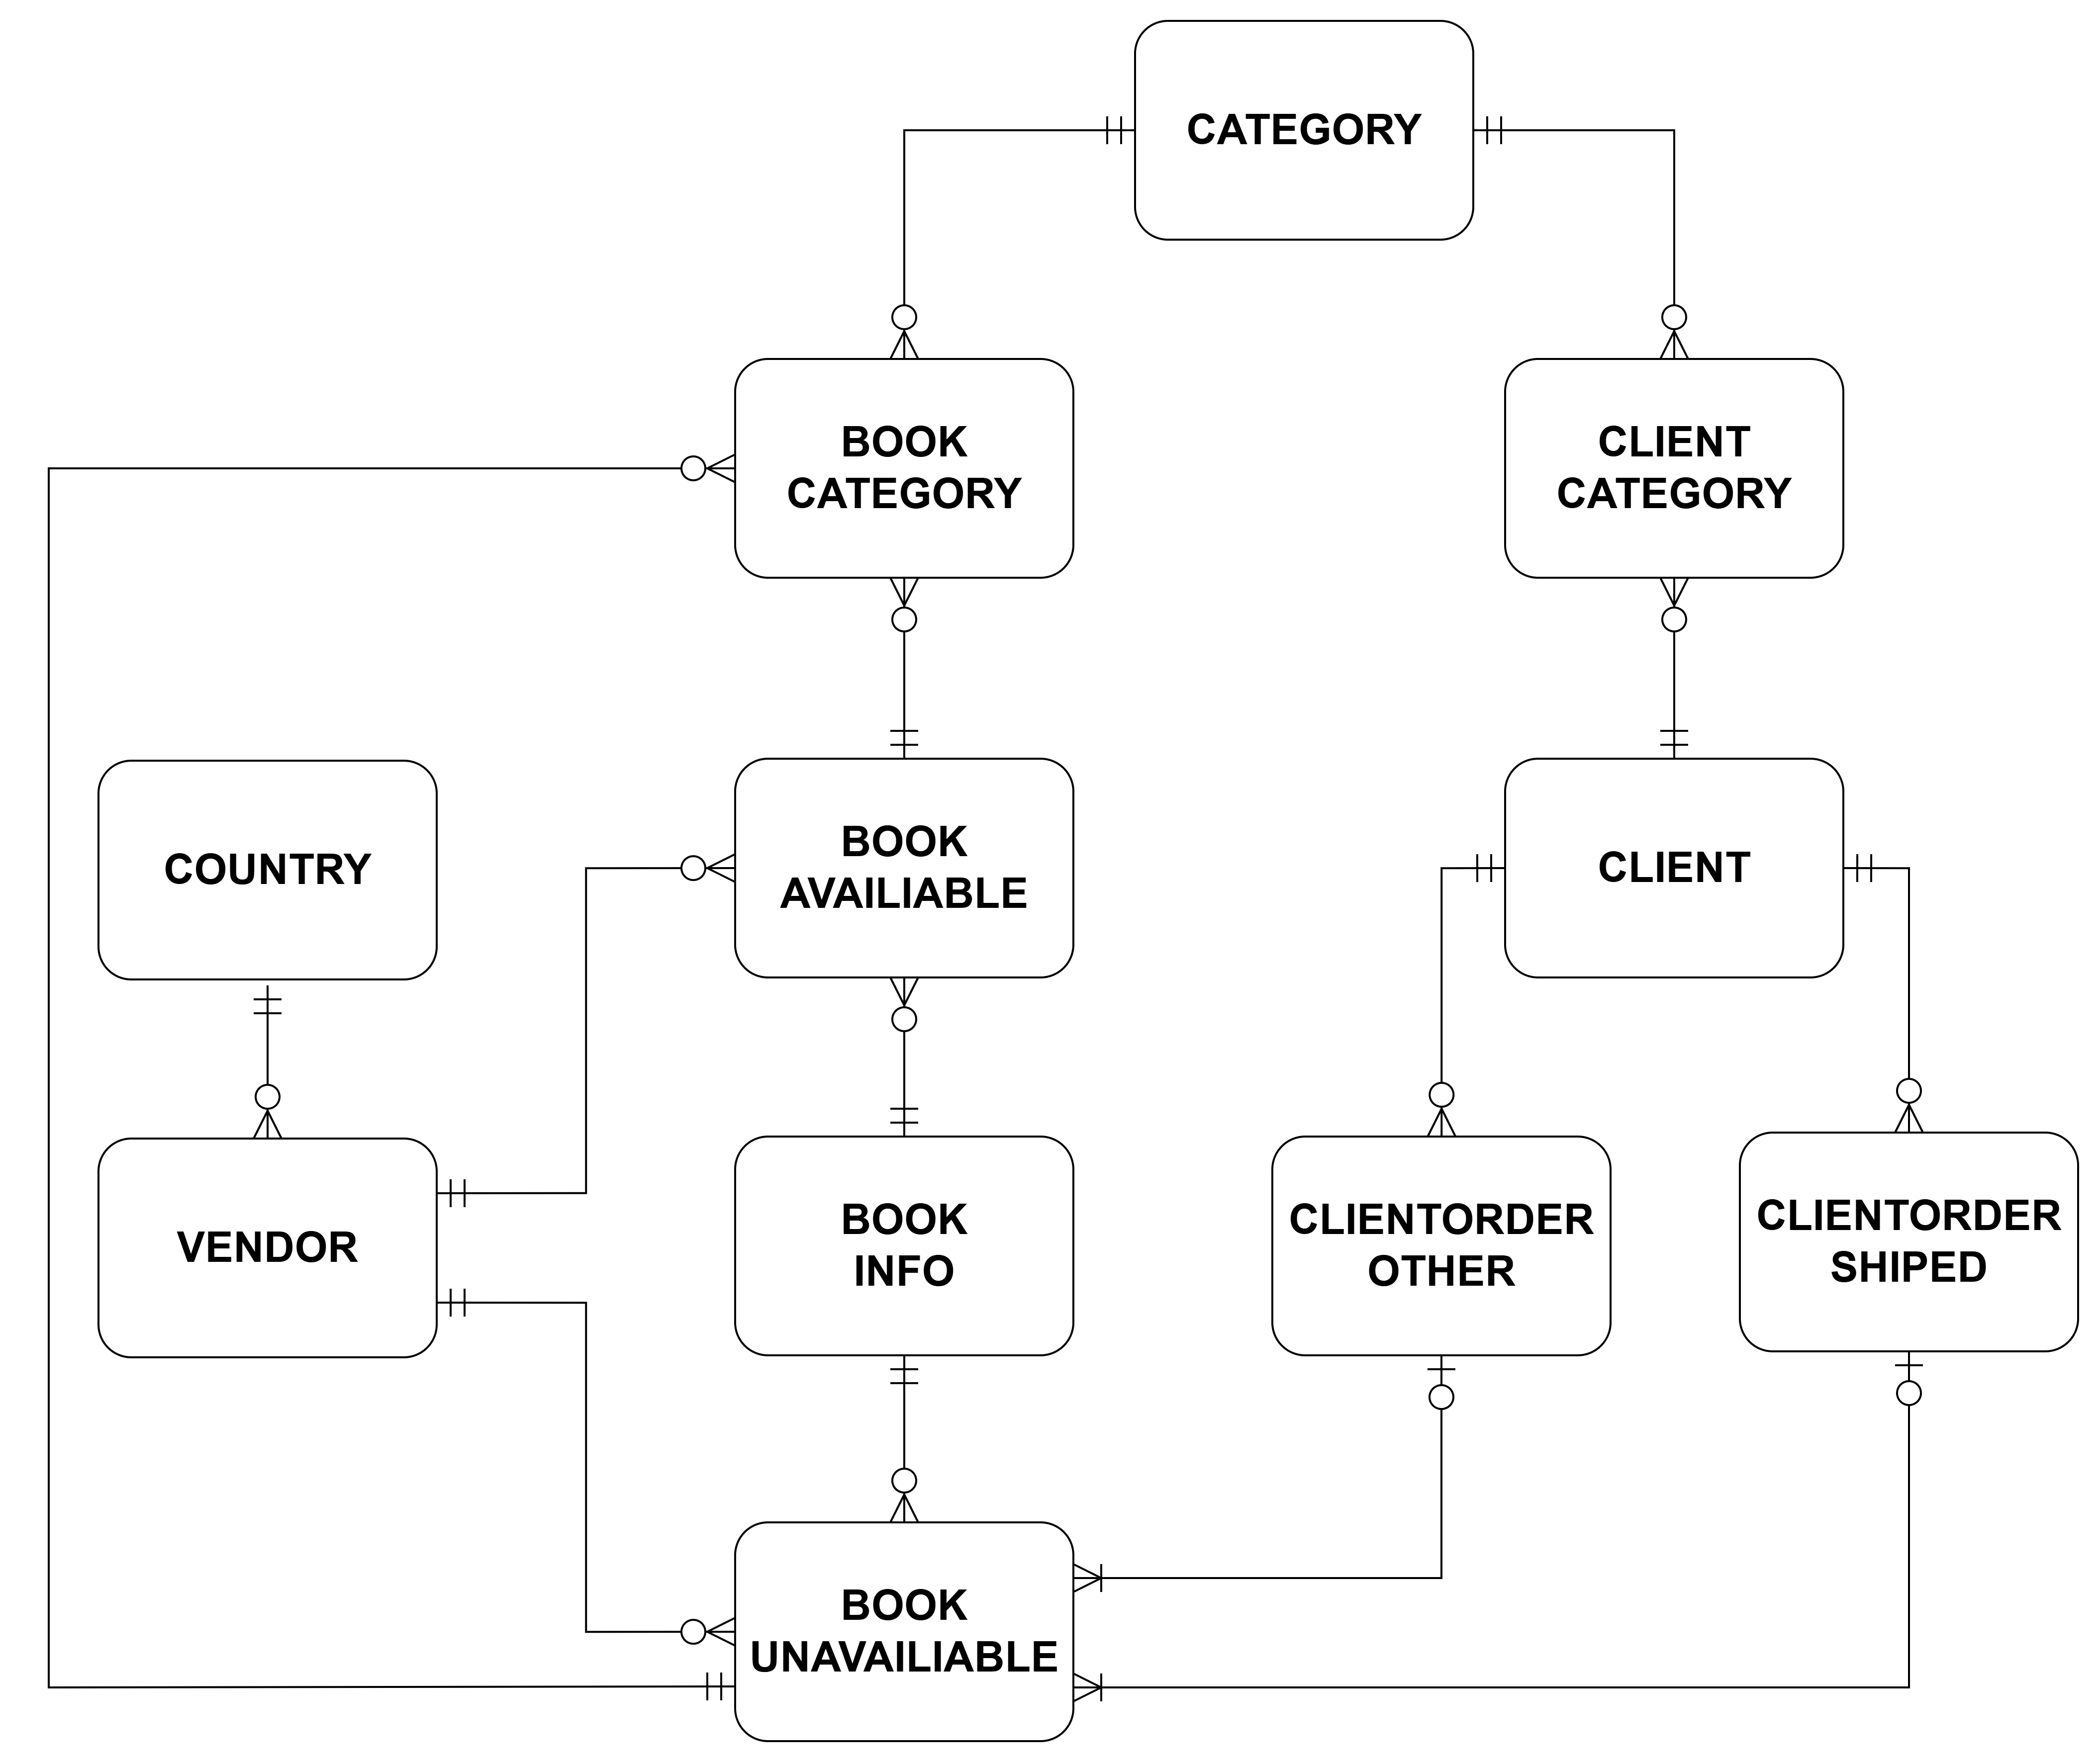

- CLIENT (ClientID, LastName, FirstName, StreetAddress, Suburb, City,
CountryID*, CreditStatus, PhoneNumber, CountryName)
CREATE INDEX ClientName_IDX ON Client (LastName, FirstName);
CONSTRAINT Client_CountryID_FK REFERENCES Country(CountryID) ON DELETE RESTRICT

- ClientOrderShipped (ClientOrderID, OrderDate, ClientID*, Status)
CREATE INDEX OrderClientID _IDX ON CLIENTORDER (ClientID);
CONSTRAINT OrderShipped_ClientID_FK REFERENCES Client(ClientID) ON DELETE RESTRICT

- ClientOrderOther (ClientOrderID, OrderDate, ClientID*, Status)
CREATE INDEX OrderClientID _IDX ON CLIENTORDER (ClientID);
CONSTRAINT OrderOther_ClientID_FK REFERENCES Client(ClientID) ON DELETE RESTRICT

- VENDOR (VendorID, VendorName, CountryID*, Email, ContactLastName, ContactFirstName, ContactEmail)
CREATE INDEX VendorName_IDX ON Vendor (vendorname);
CONSTRAINT Vendor_CountryID_FK REFERENCES Country(CountryID) ON DELETE RESTRICT

- BookInfo (BookInfoID, Title, Notes, LastName, FirstName)
CREATE INDEX InfoTitle_IDX ON BOOKINFO (Title);

- BookAvailable (BookID, Cost, Price, Available, DatePublished,
BookInfoID*, VendorID*, ClientOrderID*)
CREATE INDEX BookInfoID_VendorID_IDX ON BookAvailable (BookInfoID, VendorID);
CONSTRAINT BookAvailable_BookInfoID_FK REFERENCES BookInfo(BookInfoID) ON DELETE RESTRICT
CONSTRAINT BookAvailable_VendorID_FK REFERENCES Vendor(VendorID) ON DELETE RESTRICT

- BookUnavailable (BookID, Cost, Price, Available, DatePublished,
BookInfoID*, VendorID*, ClientOrderID*)
CREATE INDEX BookInfoID_VendorID_IDX ON BookUnavailable (BookInfoID, VendorID);
CREATE INDEX BookClientOrder_IDX ON BookUnavailable (ClientOrderID);
CONSTRAINT BookUnavailable_BookInfoID_FK REFERENCES BookInfo(BookInfoID) ON DELETE RESTRICT
CONSTRAINT BookUnavailable_VendorID_FK REFERENCES Vendor(VendorID) ON DELETE RESTRICT
CONSTRAINT BookUnavailable_ClientOrderID_FK REFERENCES ClientOrderOther(ClientOrderID) ON DELETE SET NULL

- BOOKCATEGORY (BookID*, CategoryID*)
CONSTRAINT BookCategory_BookID_FK REFERENCES BookUnavailable(BookID) ON DELETE CASCADE
CONSTRAINT BookCategory_BookID2_FK REFERENCES BookAvailable(BookID) ON DELETE CASCADE
CONSTRAINT BookCategory_CategoryID_FK REFERENCES Category(CategoryID) ON DELETE RESTRICT

- CLIENTCATEGORY (ClientID*, CategoryID*, CC_Level)
CREATE INDEX CategoryID_BookID_IDX ON CLIENTCATEGORY (BookID, CategoryID);
CONSTRAINT ClientCategory_CategoryID_FK REFERENCES Category(CategoryID) ON DELETE RESTRICT
CONSTRAINT ClientCategory_ClientID_FK REFERENCES Client(ClientID) ON DELETE CASCADE

- COUNTRY (CountryID, CountryName)
- CATEGORY (CategoryID, Description)

  - Redevelop the two data usage maps based on your findings in question 5. (5 marks)
- All shipped orders for all clients run on average 4 times a day

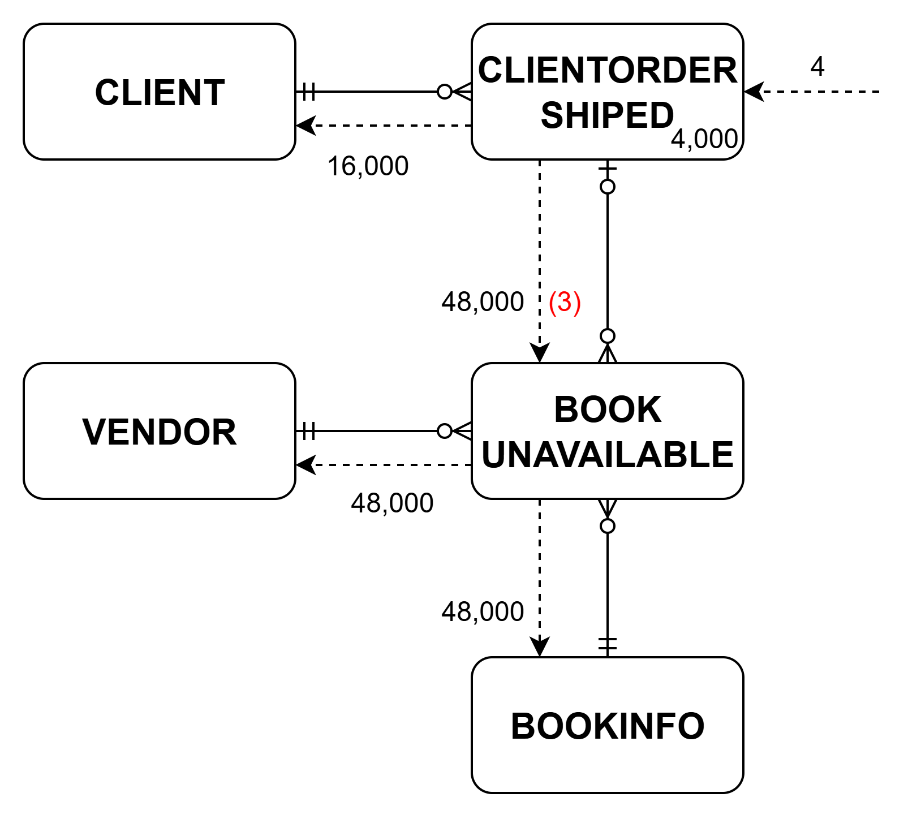
- All vendors and available books run on average 3 times a day
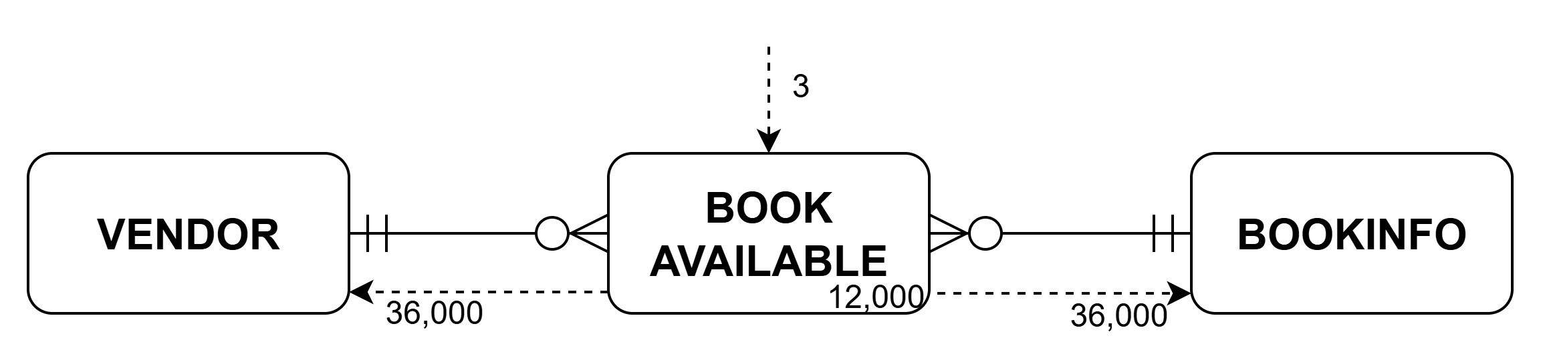

  - Interview (10 mins per group). Each group will be interviewed separately based on the timetable of interviews (TBA). No extra documentation (e.g., slide show) is required.

- Justify your choices and explain your reasoning
- Answer follow-up questions about your recommendations
(35 marks)

Assignment submission instructions:

- Upload your assignment via the Moodle Link “Assignment”.

Marking Schedule

Your report should defend the correctness of your solution. Please do not include repeated or unnecessary information in the report. The marking criteria will include correctness of the solution, difficulty of implementation, completeness, accuracy, clarity and good structure of the report.

Section | Maximum Marks Available
Physical Design
Data Volume Map | 5
Data Usage Maps | 5
Business function (process) to physical design technique matrix | 10
Physical Design Considerations | 30
Final ERD with relations (and on-delete actions) | 10
Redeveloped Data Usage Maps | 5
Interview | 35
Provisional Total | 100
Administrative Deductions
Actual Total

Have a query? Want to improve your work?
You could:
- Visit Student Learning and Achievement for learning advice and support.
- Visit the Pacific Centre.
- Visit Te Puna Ako

Assignment Hand-in

Electronic submission of the assignment is required for ALL assignments (excluding questions). This copy must be submitted on Moodle prior to the due date.

Assignments submitted after the due date and time will be penalised according to the following:
• 10% of marks deducted if submitted within 24hrs of the deadline
• 20% of marks deducted if submitted after 24hrs and up to 48hrs of the deadline
• 30% of marks deducted if submitted after 48hrs and up to 72hrs of the deadline
• No grade will be awarded for an assignment that is submitted later than 72hrs after the deadline.

Affected Performance Consideration (APC)

Students who, due to circumstances beyond their control, miss an assignment deadline or consider their performance in an assignment to have been adversely affected, should complete the form available from any Student Services Office. You need to submit the form and a medical certificate or documentary evidence that shows the circumstances were beyond your control. You have a maximum of five working days to submit the APC application.

When applying for a APC for an extension to an assignment you need to submit the assignment work completed so far on the day that the assignment is due. The extension period for which you are applying cannot be greater than the time frame on the documentation you submit. For example, a Doctor's Certificate stating you are sick for two days will entitle you to a maximum of a two-day extension.

Assistance to other Students

Students themselves can be an excellent resource to assist the learning of fellow students, but there are issues that arise in assessments that relate to the type and amount of assistance given by students to other students. It is important to recognise what types of assistance are beneficial to another’s learning and also what types of assistance are unacceptable in an assessment.

Beneficial Assistance
- Study Groups.
- Discussion.
- Sharing reading material.
- Testing another student’s programming work using the executable code and giving them the results of that testing.
Unacceptable Assistance

- Working together on one copy of the assessment and submitting it as own work.
- Giving another student your work.
- Copying someone else’s work. This includes work done by someone not on the course.
- Changing or correcting another student’s work.
- Copying from books, Internet etc. and submitting it as own work. Anything taken directly from another source must be acknowledged correctly: show the source alongside the quotation.

